LOAN AGREEMENT (INDIVIDUAL)

BETWEEN

NNAMDI JOSEPH EGERUE
(Borrower)

AND

OPTIMUS BANK LIMITED
(Lender)

LOAN AGREEMENT

THIS LOAN AGREEMENT is made this 24th day of August 2023, BETWEEN NNAMDI JOSEPH EGERUE of 3, EHORO CRESCENT ELELENWON, RIVERS STATE (Hereinafter referred to as “the Borrower” which expression shall where the context so admits include his/her heirs, administrators/executors, personal representative and assigns) of the one part; AND OPTIMUS BANK LIMITED, a Bank incorporated under the laws of Nigeria and having its registered address at 55, Bishop Oluwole Street, Victoria Island, Lagos State (hereinafter referred to as “the Bank” or “the Lender” which expression shall where the context so admits include its successors-in-title and assigns) of the other part.

WHEREAS:

- The Borrower has applied for a Personal Loan Against Bet9ja commissions; bonuses; profits and other benefits, in the sum of ₦15,000,000 (FIFTEEN MILLION NAIRA ONLY) to enable the Borrower meet personal needs (hereinafter called the “Loan” or “Facility”).
- The Bank has agreed in the usual banking terms to extend to the Borrower the said Facility in the sum stated in the Offer Letter dated August 24, 2023 on terms and conditions contained in this Loan Agreement and the Offer Letter, the terms of which are hereby incorporated into this Agreement.

NOW THIS DEED WITNESSETH as follows: -

  - In this Agreement unless otherwise provided, the terms: -

BANK means OPTIMUS BANK LIMITED

BORROWER means NNAMDI JOSEPH EGERUE

BUSINESS means the operation/ employment as a KC Gaming Networks Ltd (Bet9ja) agent/super-agent/master agents or any other services applicable now or in the future.

FACILITY means the facility made available to the Borrower under this Agreement.

FINANCE DOCUMENT means this Loan Agreement, the Security Documents, Offer Letter and any other document designated by the Bank as a Finance Document or creates a right in favour of the Bank with respect to the Facility.

LOAN AGREEMENT means this Agreement as originally executed or if subsequently amended, varied or supplemented from time to time, then such amendments or variations shall be included in the meaning.

DRAWDOWN means the disbursement of the Facility by the Bank.

AVAILABILITY PERIOD means the period commencing from the date on which the conditions precedent set out in Clause 7 are satisfied.

INTEREST means the interest rate applicable to the Facility as set out in Clause 6 of this Agreement.

OFFER LETTER means the Bank’s Offer letter dated August 24, 2023 accepted by the Borrower or its representative, as may be amended, supplemented, extended or novated from time to time.

SECURITY Domiciliation of Borrower’s commissions, bonuses, profits and
benefits from KC Gaming Networks Ltd (Bet9ja)

SECURITY DOCUMENT means any document evidencing or creating security (expressly or by implication) in favour of the Bank over any asset or right in respect of the Borrower’s obligations to the Bank in connection with the Facility.

EVENTS OF DEFAULT means any of the events mentioned in Clause 9 and includes any event, which with the giving of notice and/or lapse of time and/or a determination being made under the relevant clause would be an event of default.

MONTH means calendar month.

WORKING DAY means a day on which Banks, Insurance companies and other Financial Houses open for all lawful and relevant business.

Clause headings are for convenience of reference only and shall be ignored in the interpretation of this Agreement.

LOAN AND TERMS

In consideration of the Bank granting to the Borrower the Facility in the sum of
₦15,000,000 only , the Borrower hereby covenants with the Bank subject to the terms and conditions hereinafter contained to pay all the sums which shall for the time being be due and owing to the Bank including all interest, usual commissions, customary banking charges and all costs and expenses incurred in connection with or incidental to the preparation and perfection of this Loan Agreement and all other security documents required as well as the recovery of the Facility.

TENOR

The Facility shall be for a tenor of fifty (52) weeks as advised in the Offer Letter.

REPAYMENT

    - Subject to the terms and conditions hereinafter contained, the Borrower shall repay the Facility by way of equated weekly deduction of Principal and interest through direct debit to domiciled account as advised in the Offer Letter and throughout the loan tenor; or as may be advised by the Bank from time to time.

    - The Facility may be prepaid in whole or in part at anytime provided the amount to be prepaid shall include the relevant portion of the outstanding Principal as well as the applicable interest, commissions and fees calculated on the basis of the furthest maturity had the Facility not been prepaid.

AVAILABILITY

Without prejudice to the other provisions of this Agreement and other Finance Documents, the Facility shall immediately be made available to the Borrower upon satisfactory compliance, in the sole discretion of the Bank, with the conditions as contained in the Offer Letter.

INTEREST PAYMENTS AND CAPITALIZATION

The Borrower shall until the repayment of the Facility to the Bank pay interest on the balance outstanding and on all monies whatsoever at any time owing to the Bank at the rate of 22% per annum (floating), subject to review by the Bank from time to time. The Borrower hereby acknowledges that the Bank may vary/revise the interest rate after drawdown of the facility arising from any change in market conditions or as required by regulation, and the Borrower irrevocably agrees to be bound by the varied/revised rate PROVIDED that the Bank shall give the Borrower ten (10) days’ notice before the varied/revised rate become effective.
Interest shall be calculated on the outstanding balance owing from day to day and be payable by such agreed instalments or as otherwise communicated by the Bank PROVIDED ALWAYS that if any interest required by this Agreement to be paid shall not be paid on the day on which the same shall have become payable, then without prejudice to any or all of the rights and remedies accruing to the Bank consequent upon such default, such interest(s) payable on arrears of interest capitalized under this present clause shall remain unpaid after the day on which same ought to have been paid, the same shall be added for all purposes to the general balance of the Facility and shall thenceforth bear interest payable at the rate and on the date aforesaid and all the terms and provisions of this agreement and rules of law in relation to interest on the balance of current or other account shall equally apply to interest on such arrears.

In the event that any payment is not made on its due date, a late repayment fee per month shall be applied on any outstanding unpaid obligation. This is without prejudice to the fees set out in the Offer Letter.

CONDITIONS PRECEDENT

The obligation of the Bank to disburse the Facility hereunder shall be subject to the terms and conditions set out in the Offer Letter.

COVENANTS AND CONDITIONS

The Borrower hereby covenants with the Bank that so long as any part of the Facility or interest or other moneys hereby covenanted to be paid remains outstanding, the Borrower shall:

- The Borrower will also from time-to-time supply to the Bank such other information as the Bank shall reasonably require in respect of the assets and liabilities of the Borrower.

- The Borrower hereby irrevocably undertakes to fully liquidate the outstanding balance on the facility herein granted in the event that the Borrower decides to exit the business or sell-off their location/Agency right, which liquidation shall be effected on or before the effective date of such sell-off or termination of agency business/right

- promptly, upon becoming aware of them, deliver to the Bank details of any litigation, arbitration or administrative proceedings which are current, pending or threatened, which if adversely determined, would have an adverse effect on the Borrower.

EVENTS OF DEFAULT

- Notwithstanding anything express or implied herein contained and without prejudice to any other Events of Default stipulated in any other Finance Document, the Facility or the balance for the time being shall become immediately repayable and all unpaid interest, which has accrued hereunder, shall become immediately payable:

  - If the Borrower defaults in the repayment of any monies due hereunder and continues to so default for a period of 7 (seven) days; or

  - If any court order is made which attaches the Borrower’s assets or account balances with the Bank or any other financial institution including a Garnishee order absolute wherein the Borrower is the judgment debtor; or

  - If the Borrower stops payment or ceases/ threatens to cease to carry on business; or

  - If any distress, execution, sequestration, or other process is levied or enforced upon or issued out against the property of the Borrower and is not discharged within 5 (five) days; or

  - If the Borrower commits any breach of this Agreement or any other Finance Document; and in the case of any breach capable of remedy fails to remedy the breach within 7 (seven) days of the breach; or

  - If the property of the Borrower or any part thereof is compulsorily acquired by any order of any government or other authority and in consequence the business of the Borrower is in the opinion of the Bank seriously affected; or

  - If any representation or warranty made by the Borrower in this Agreement, any other Finance Document, any notice, certificate or statement delivered or made pursuant thereto proves to have been incorrect or materially inaccurate when made or delivered; or

  - If any litigation shall be commenced before any court of governmental authority to restrain the execution and performance of this Agreement or to question the execution thereof, the Bank, shall enforce its claim against the Borrower, by written notice to the Borrower declaring that the Facility outstanding has become immediately due and payable with accrued interest thereon; or

  - If any extraordinary situation shall have arisen the continuance of which in the opinion of the Bank shall make it impossible or improbable that the Borrower will be able to perform its obligations under the Finance Documents; or

  - If it becomes illegal, or if the Bank deems it improper or undesirable for the Facility to remain outstanding; or
  - If there should, in the opinion of the Bank, be a material adverse change in the financial condition of the Borrower; or the occurrence of any event or circumstance which in the Bank’s opinion is reasonably likely to have a Material Adverse Effect. For the purpose of this clause, “Material Adverse Effect” means any event or circumstance which in the opinion of the Bank would have an adverse effect on:

    - the business, operations, assets, condition (financial or otherwise) or prospects of the Borrower;

    - the ability of the Borrower to perform its obligations under this Agreement or any Finance Document;

    - the validity or enforceability of the Finance Documents or the rights or remedies of the Bank under the Finance Documents.

- At any time after an Event of Default as defined above occurs, the Facility together with the accrued interest thereon and any other amounts payable under the Finance Documents shall be deemed to be immediately payable; and/or the Facility shall be cancelled; and the Bank shall be entitled to exercise its remedies as available to it herein.

- As a continuing obligation, the Borrower shall indemnify the Bank against all damages or losses (including but not limited to legal cost for enforcement of this Undertaking), losses, actions, claim, expenses, demands and liabilities of whatever nature nor or hereafter incurred by the Bank for anything done or omitted to be done whether in exercise or purported exercise of the powers herein contained, in connection with or arises out of this Loan or occasioned by a breach of the Borrower’s obligations hereunder which may be sustained or incurred by the Bank, OR as a consequence of the occurrence of an Event of Default. For this purpose, a certificate from the Bank as to the amount of any such loss or expense shall be final and conclusive save in the case of a manifest error., the Borrower agrees to indemnify the Bank and keep the Bank indemnified in full against all cost.

(IV). In the event that the Borrower fails or defaults in repaying the loan as agreed, the Bank reserves the right at its discretion, to transfer the defaulting account to a third-party agency/firm to recover any outstanding debt due to the Bank. In addition, in the event of a loss of job leading to a default, the Bank shall transfer the defaulting account to the designated insurance company to recover any outstanding debt paid on behalf of the Borrower; and

(v) In the event of the exit of the Borrower from the business, while the loan facility or any part thereof remains outstanding, such outstanding sum shall be immediately become due and liquidated to the Borrower’s current account, while the interest thereon shall commence at the Bank’s commercial lending rate in line with prevailing market conditions and extant regulation/ regulatory directive.

INDULGENCE

The Bank may without prejudice to its rights herein enter into any Agreement for giving time or other facilities to the Borrower in respect of the Facility or other monies hereby covenanted to be paid or any part thereof and may release or compound same with the Borrower or any person, company or corporation liable to pay the same.

REMEDIES AND WAIVERS

- No failure to exercise nor any delay in exercising on the part of the Bank any right or remedy hereunder shall operate as a waiver thereof nor shall any single or partial exercise of any right or remedy prevent any further or other exercise thereof or the exercise of any other right or remedy.

- The rights and remedies herein provided are cumulative and not exclusive of any rights or remedies provided by law.

ASSIGNMENT

The Bank shall be entitled to assign any of its rights and powers under this Agreement, with all or any of the obligations herein stated and may assign and and/or deliver to any such assignee the security collateral hereto and in the event of such assignment, the assignee thereof shall have the same rights and remedies as if originally named therein in place of the Bank and thereafter the Bank will be fully discharged from all responsibility with respect to any such security so assigned or delivered.

REPRESENTATIONS AND WARRANTIES

The Borrower makes the following representations and warranties to and for the benefit of the Bank which representations and warranties shall survive the execution of this Agreement and the granting of the Facility: -

- For the purpose of enforcing this Loan Agreement, the Borrower hereby irrevocably authorize the Bank to act in [his/her] name to take any necessary or appropriate steps in respect of the enforcement of rights granted or accruing hereunder. This Power of Attorney shall remain in full force and effect throughout the validity of this Loan Agreement.
- All consents, licenses, approvals, authorizations or exemption of any Governmental or other regulatory authority bureau or agency, if any, required on the part of the Borrower for or in connection with the validity performance admissibility in evidence or enforceability of this Agreement have been obtained, and shall remain in full force and effect and true copies hereof have been delivered to the Bank and conditions therein or otherwise applicable have been or will at the appropriate time be complied with or fulfilled.

- The Borrower has the power to enter into and perform this Agreement and to borrow hereunder and has taken all necessary action to authorize the borrowing of the Facility upon the terms and conditions of this Agreement and the other Facility Documents.
- The Borrower hereby authorizes the Bank to debit his/her account for the weekly Loan repayment obligations comprising principal and interest and any default fees where applicable and unconditionally agrees that the interest charged on the Loan shall be at the Bank’s prime lending rate from time to time.
- All factual information provided by the Borrower to the Bank is true and accurate in all material respects.
- No Event of Default is outstanding or will result from the entry into of, or the performance of any obligation contemplated by any Facility Document.

ACCOUNTS

The Bank shall open in its books such accounts as may be necessary to show satisfactory evidence of indebtedness. Save in the case of manifest error, the amounts outstanding in these accounts shall be construed to be the amounts outstanding on principal and interest under this Facility Agreement.

FEES AND EXPENSES

The Borrower shall bear all statutory and professional costs to be incurred for the stamping of this Agreement.

RIGHT OF SET-OFF

    - The Borrower agrees that the Bank may at any time without notice or further demand notwithstanding any settlement of account or any matter whatsoever, combine or consolidate all or any of the Borrower’s then existing account wherever situate and any accounts in the name of the Borrower jointly with others and set-off or transfer any sum standing to the credit of any one or more such accounts in or towards satisfaction of monies owed hereunder or under any other facility.

    - Further to the above and by signing this Loan Agreement and drawing on the Loan, the Borrower covenants to repay the Loan as and when due. In the event that the Borrower fails to repay the Loan as agreed, and the Loan becomes delinquent, the Bank shall have the right to report the delinquent Loan to the Central Bank of Nigeria (“CBN”) through the Credit Risk Management System (CRMS) or by any other means, and request the CBN to exercise its regulatory power to direct all banks and other financial institutions under its regulatory purview to set-off the Borrower’s indebtedness from any money standing to the Borrower’s credit in any bank account and from any other financial assets they may be holding for the Borrower’s benefit.

    - The Borrower covenants and warrants that the Bank shall have power to set-off the Borrower’s indebtedness under this Loan from all such monies and funds standing to the Borrower’s credit/benefit in any and all such accounts or from any other financial assets belonging to the Borrower and in the custody of any such bank and/or any other financial institution.

16.4. The Bank may at any time and without notice to the Borrower, combine all or any of the Borrower’s account and liabilities with the Bank in Nigeria (or elsewhere) whether held solely or jointly with any person(s) and set off all or any monies standing to the credit of the Borrower in such accounts, including the Borrower’s deposits with the Bank (whether matured or not) towards satisfaction of any of the Borrower’s liabilities to the Bank, whether as principal or surety, actual or contingent, solely or jointly, primary or collateral with any other person and the Bank may effect any necessary currency conversion at the Bank’s own rate of exchange then prevailing. Exchange risks associated with any collateral, cash or otherwise in satisfaction of outstanding debt shall be borne by the Borrower

16.5 The Borrower hereby waives any right of confidentiality whether arising under common law or statute or in any other manner whatsoever and irrevocably agree that the Borrower shall not argue to the contrary before any court of law, tribunal, administrative authority or any other body acting in any judicial or quasi-judicial capacity.

NOTICES:

A notice or demand may be served by the Borrower upon the Bank by sending it through registered post addressed to the Bank or delivered by hand at its registered office at 55 Bishop Oluwole Street, Victoria Island, Lagos and any demand or notice to be made or given by the Bank may be made by letter signed by any Manager or other duly authorized officer of the Bank through registered post addressed to the Borrower or delivered by hand at the Borrower’s last known address and any demand or notice delivered by hand shall be deemed to have been served on the date of delivery thereof and any demand or notice served by registered post on either party shall be deemed to have been served at the expiration of 14 (fourteen) days after it is posted in Nigeria and proof of it shall be the registration slip issued by the post office by which the letter was posted.

ACKNOWLEDGEMENT

Any admission or acknowledgement in writing by the Borrower or by any authorized person on behalf of the Borrower of the amount of the indebtedness of the Borrower to the Bank or any judgment or award obtained by the Bank against the Borrower or any statement of account furnished by the Bank certified by any officer of the Bank, as a true copy extracted from the books of the Bank, shall be accepted as prima facie evidence of indebtedness against the Borrower.

EXECUTION OF LOAN AGREEMENT

This Facility Agreement shall be executed in any number of counterparts and all such counterparts signed by all the parties hereto separately shall be deemed to constitute one and the same instrument and the Agreement shall become effective when each of the parties hereto shall have signed a copy thereof (whether the same or different copies) and shall have delivered the same to the Bank.

The terms of the Offer Letter shall form part of the terms and conditions under which this Facility is granted, and the terms of the Offer Letter are hereby incorporated by reference into this Agreement. Notwithstanding anything to the contrary in this Loan Agreement express or implied, in the event of a conflict between the terms of this Loan Agreement and the terms of the Offer Letter, the provisions of this Loan Agreement shall prevail to the extent of the inconsistency.

APPLICABLE LAW AND CHANGES THEREIN

- This Agreement shall be governed by and construed in accordance with the Laws of the Federal Republic of Nigeria.

- If the Bank shall have determined that the introduction of a change in any applicable law or regulation or in the interpretation thereof by any administration thereof by any governmental or other regulatory authority charged with the administration thereof or court of competent jurisdiction makes it apparent that it is unlawful for the Bank to give effect to or maintain its obligations as contemplated by this Agreement, the Facility shall forthwith be cancelled and the Borrower shall on the next succeeding interest payment date or such earlier date as may be required repay to the Bank the principal amount of the Facility together with accrued interest thereon and any other amounts due to the Bank under this Agreement.

AMENDMENT OF AGREEMENT

This Agreement may be amended from time to time by the Bank as may be deemed necessary in view of circumstantial exigencies. Notice of such amendment shall be notified to the Borrower.

DATE OF AGREEMENT

This Agreement shall take effect from the date and year first above written.

DISPUTE RESOLUTION

In the event of any dispute, difference or claim arising out of or in connection with this agreement, the parties shall meet in good faith, within a month of the knowledge of the dispute, for negotiations to resolve the dispute amicably. If the dispute is not settled by negotiation within 14 days of commencement of such negotiations or within a longer period as agreed to by the parties, the dispute, difference, or claim shall be referred to the Lagos Multi-Door Courthouse for mediation which shall be concluded in accordance with the LMDC Mediation Procedure Rules, 2007 or other rules mutually agreed by the parties. Nothing in the foregoing shall be construed as precluding the Parties from seeking redress in any court of competent jurisdiction.

IN WITNESS WHEREOF the Bank and the Borrower have executed this Agreement the date and year first above written

SIGNED by the within named Borrower.

NNAMDI JOSEPH EGERUE
(Name and Signature of Borrower)

IN THE PRESENCE OF:
NAME: ADDRESS: OCCUPATION: SIGANTURE: DATE:

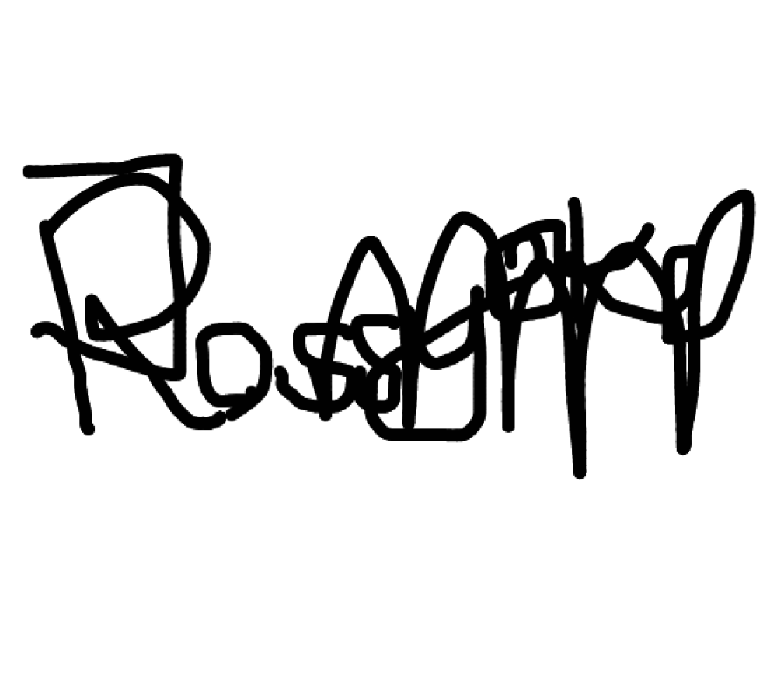
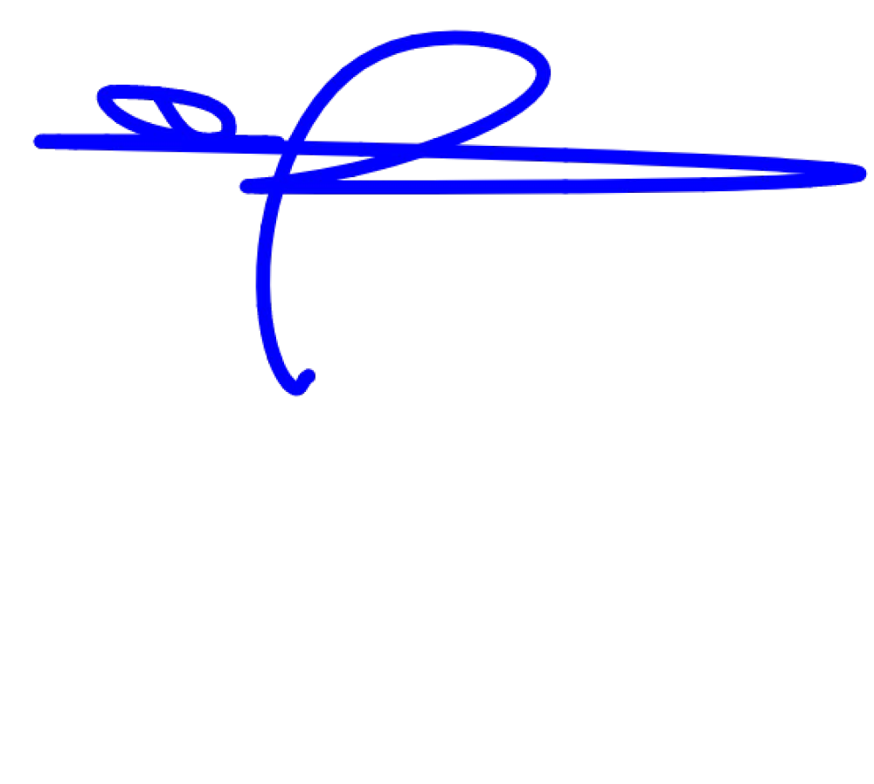
SIGNED for and on behalf of OPTIMUS BANK LIMITED

AUTHORIZED SIGNATORY AUTHORIZED SIGNATORY

